Table of Contents
Requirements 1
Introduction 1
References 1
Convolutional Neural Networks (CNN’s) 2
Common Filters (Kernels) 3
Stride 4
Padding 5
Pool Size 5
Applying Multiple Filters 5
Increasing Filters in Each Consecutive Layer 5
Kernel Size 10
Filters 10
Strides 10
Early Stopping and Saving the Best Model 14

Requirements
This was implemented using tensorflow 2.4 and keras 2.4.3.

On Windows I had to run PyCharm as Administrator.

On my Mac I had to install open CV when the CV2 module was missing. The installation required admin status: sudo pip install opencv-python

Introduction
The goal of this document is to provide a light introduction to convolutional neural networks. Tuning them can be a challenge so the focus will be more on the general terminology instead.

References
https://www.analyticsvidhya.com/blog/2017/06/architecture-of-convolutional-neural-networks-simplified-demystified/

https://medium.com/@RaghavPrabhu/understanding-of-convolutional-neural-network-cnn-deep-learning-99760835f148#:~:text=Strides,with%20a%20stride%20of%202.

Convolutional Neural Networks (CNN’s)
Convolutional Neural Networks, or CNNs for short, are a type of network designed for image input. They are comprised of models with convolutional layers which extract and transform features into simpler pooled elements. The pooled features are then flattened into arrays which are fed through a neural network for classification.

Figure 1: Feature Pooling and Classification Activities of a Convolutional Neural Network
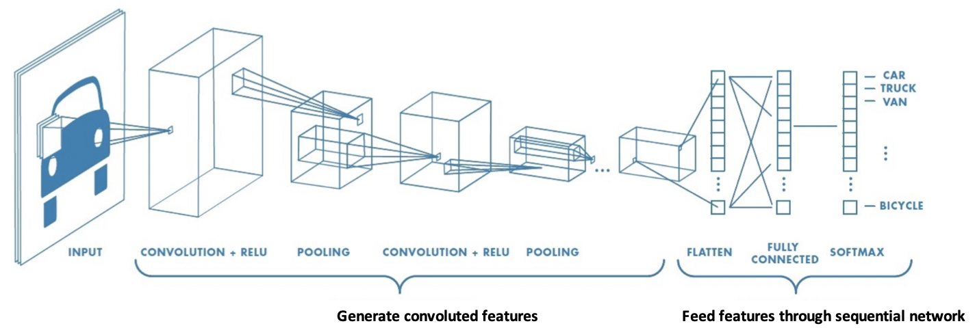

Figure 2 shows how nine pixels of an image can be convoluted into one element of a pooled layer. Notice how the pooled layer dimensions are much smaller than the original image.

Figure 2: Transforming Nine Elements into One Pooled Element
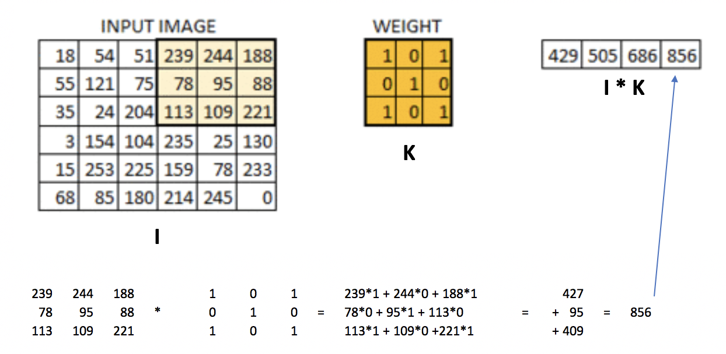
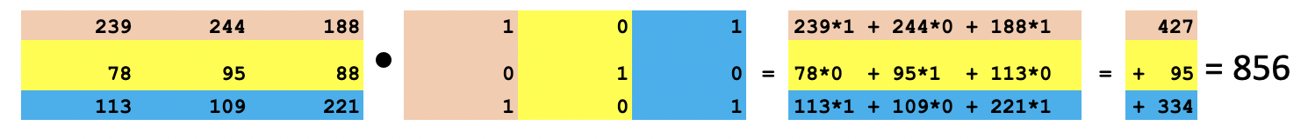

Convolving with a filter creates a feature map like the one in Figure 3.

Figure 3: Real Image vs. Convoluted Image
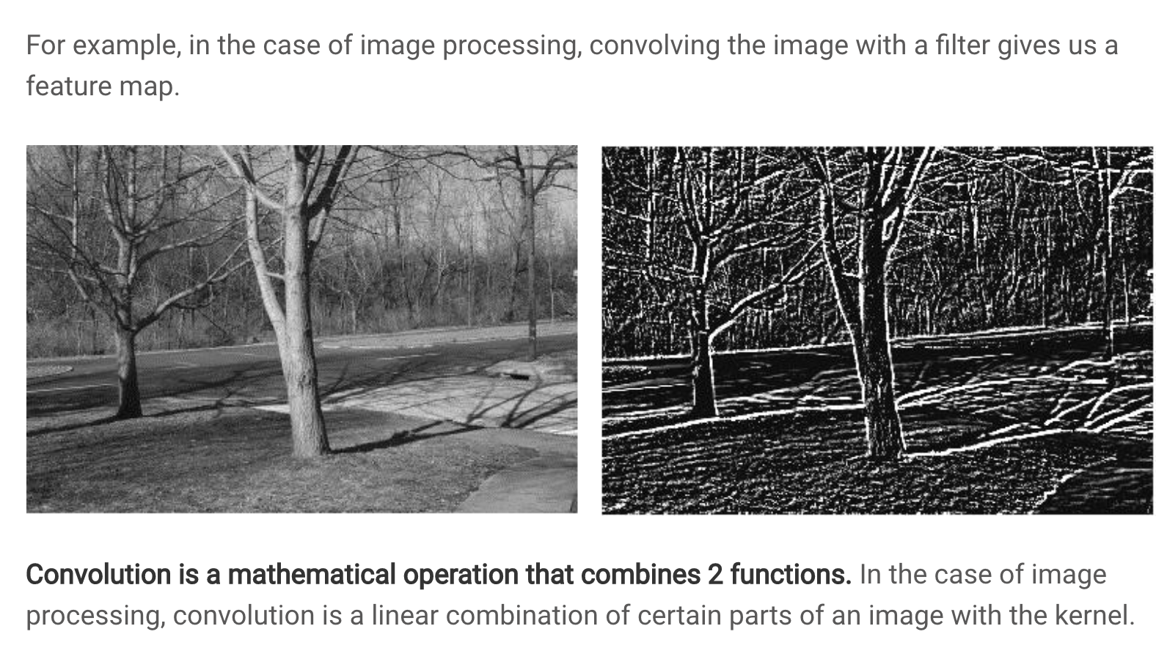

Common Filters (Kernels)
Not all filters are the same. Figure 4 highlights several filter types.

Figure 4: Common Image Filters
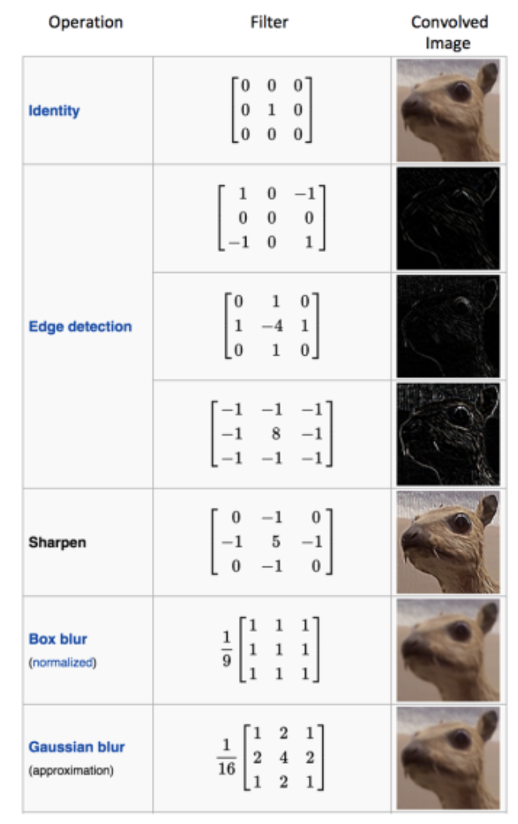

Stride
Like we saw in Figure 2 the weight matrix was applied to sub sections of the image. In the example given, the sub sections were selected by shifting a window horizontally across the original image one pixel at a time and then down one pixel at a time. This stride of 1 pixel x 1 pixel led to a convoluted image that is 4x4 pixels. Lower strides leads to a higher amount of detail in the convoluted image.

A higher stride of 2x2 leads to a smaller convoluted image. Figure 5 illustrates a how a convoluted image is created with a filter by using a 2x2 stride. The first section of the image is selected and is filtered. Then the selection is shifted two pixels across. The new selection is multiplied by the filter. Then the selection is taken from the bottom left of the original image and is multiplied by the filter. Then the selection is taken from the bottom right of the image and this section is multiplied by the filter.

Figure 5: Creating a Convoluted Image with a 2x2 Stride
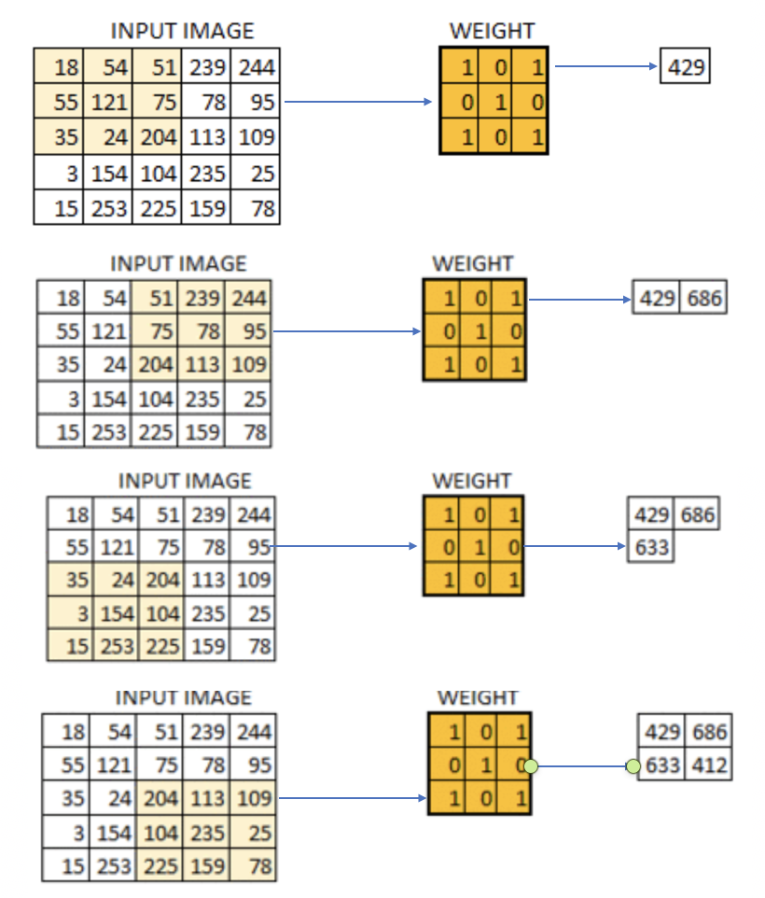
Exercise 1 (3 marks)
Show the calculation needed to multiply the section of the input image by the filter to generate 686. See Figure 5.
Calculations are happening here
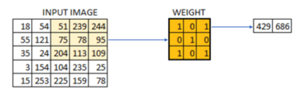
51*1 + 239*0 + 244*1 = 51 + 244 = 295
75*0 + 78 * 1 + 95*0 = 78 = 78
204*1 + 113*0 + 109*1 = 204 + 109 = 313
295 + 78 + 313 = 686

Exercise 2 (4 marks)
Mark the following sentence true or false.
- Increasing the stride leads to a higher rate of image down sampling: i) True ii) False.
- Higher rates of image down sampling preserves more image detail compared to lower rates of down sampling: i) True ii) False.
- A larger kernel leads to lower rates of image down sampling: i) True ii) False.
- Kernel refers to the sliding window size in a CNN: i) True ii) False.

Padding
You may have noticed that striding across the image leads to a smaller convoluted image. However, we could pad the border with zeros to retain the original size of the image. Padding also allows us to obtain more information about the borders (see Figure 6).

Figure 6: Padding an Image
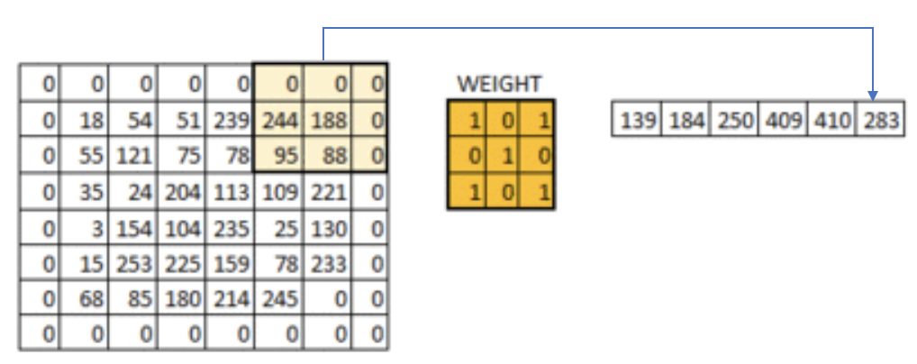

Pool Size
A pool_size attribute is used in the network to downsample the image. The calculation used for downsampling is:

output_shape = (input_shape - pool_size + 1) / strides)

Applying Multiple Filters
If we have a 32x32 image with a 3-byte color layer and we apply a stack of ten 5x5x3 filters we end up with a convoluted output of 28x28x3.
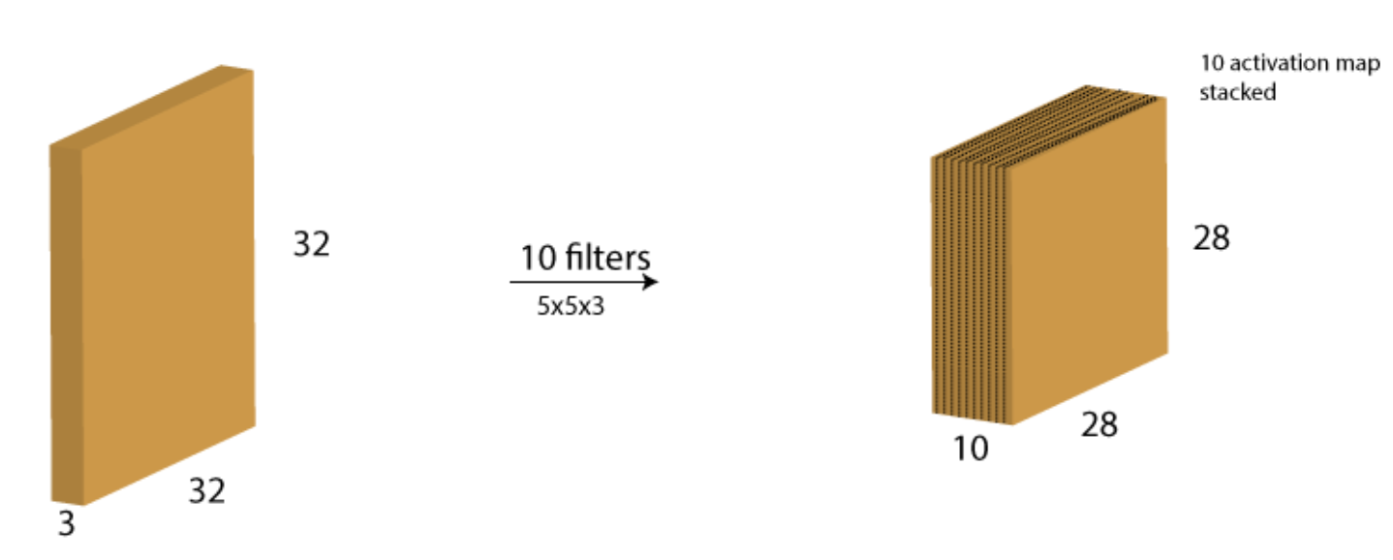

Increasing Filters in Each Consecutive Layer
In every layer filters are there to capture patterns. For example in the first layer filters capture patterns like edges, corners, dots etc. In the subsequent layers we combine those patterns to make bigger patterns. Like combine edges to make squares, circle etc.

Now as we move forward in the layers the patterns gets more complex, hence larger combinations of patterns to capture. That's why we increase filter size in the subsequent layers to capture as many combinations as possible.
https://datascience.stackexchange.com/questions/55545/in-cnn-why-do-we-increase-the-number-of-filters-in-deeper-convolution-layers-fo

Example 1: Processing and Displaying Images
This first example demonstrates how to prepare the images for modelling.

Initially the images are loaded.
img = cv2.imread(filePath)

The images are then scaled to a size of 96x96 pixels.
img = cv2.resize(img, (IMAGE_SIZE, IMAGE_SIZE))

Next, the code eliminates the 3 byte color channel.
img = cv2.cvtColor(img, cv2.COLOR_RGB2GRAY)

To understand our image data better some print statements are used to display the data attributes and contents.

print("Image Label: " + str(labels[index]))
print("Image Shape: " + str(images[index].shape))
print("Image Data: ")
print(images[index])

Image Label: 0
Image Shape: (96, 96)
Image Data:
[[0.06666667 0.03137255 0.01568627 ... 0.14901961 0.16470588 0.38039216]
[0.02352941 0.05098039 0.03137255 ... 0.18039216 0.21568627 0.37254902]
[0.03921569 0.03137255 0.03529412 ... 0.18823529 0.2 0.32941176]
...
[0.30196078 0.27843137 0.29019608 ... 0.34901961 0.36470588 0.36470588]
[0.33333333 0.32156863 0.31764706 ... 0.3372549 0.33333333 0.33333333]
[0.34901961 0.31764706 0.32941176 ... 0.33333333 0.33333333 0.35294118]]

To verify that the images are process properly, two processed test images are displayed on the screen.

plt.imshow(images[index])
plt.show()
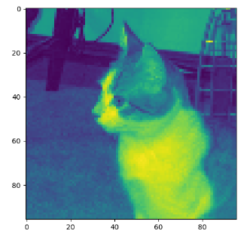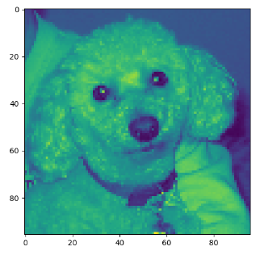

Note that depending on whether you are using Windows or Mac, please make the adjustments in the two sections that are highlighted below.
import matplotlib.pyplot as plt
import os
import numpy as np
import cv2

PATH = '/users/pm/desktop/daydocs/data/small_cats_and_dogs/'

# Loads the image file.
def load_image(fileName, subFolder):
try:
folder = PATH + subFolder + "\\" # Windows
folder = PATH + subFolder + "/" # Mac
filePath = folder+ fileName
img = cv2.imread(filePath)
return img
except:
return np.NaN

# Extract the actual class from the image file name.
def extract_label(file_name):
return 1 if "dog" in file_name else 0

# Transforms image into scaled and squared image.
def preprocess_image(img):
IMAGE_SIZE = 96

try:
# Finds minimum of height and width.
min_side = min(img.shape[0], img.shape[1])

# Reduce image to square using minimum of width and height.
img = img[:min_side, :min_side]

# Reside to 96x96.
img = cv2.resize(img, (IMAGE_SIZE, IMAGE_SIZE))
print(img.shape)

# Eliminate three byte color channel.
img = cv2.cvtColor(img, cv2.COLOR_RGB2GRAY)
print(img.shape)
print("***")

# Scale numbers to range between 0 and 1.0
return img / 255.0
except:
return np.NaN

def getImages(dirName):
imageList = []
labelList = []

# List all items in the directory.
# image_files = os.listdir(PATH + dirName + "\\") # Windows
image_files = os.listdir(PATH + dirName + "/") # Mac

for i in range(0, len(image_files)):
image = load_image(image_files[i], dirName)
processedImage = preprocess_image(image)

# Build list of processed images and labels.
if processedImage is not np.NaN:
imageList.append(processedImage)

label = extract_label(image_files[i])
labelList.append(label)
return imageList, labelList

# Displays grayscale image and image data to ensure everything is working properly.
def verifyImage(images, labels, index):
print("Image Label: " + str(labels[index]))
print("Image Shape: " + str(images[index].shape))
print("Image Data: ")
print(images[index])

# Display the image.
plt.imshow(images[index])
plt.show()
print("*****")

# Add an extra dimension for the signle color channel.
# Changes (2000, 96, 96) to (2000, 96, 96, 1)

# Load transformed and scaled images.
X_train, y_train = getImages('train')
X_test, y_test = getImages('test')

# Verify first image in training set.
verifyImage(X_train, y_train, 0)

# Verify second image in training set.
verifyImage(X_train, y_train, 1)

Example 2: Convert to 3D Array
Like other neural network examples, we need to ensure our inputs are in vertical array format to enable matrix multiplication. This code transforms our data into a vertical array. Here is the shape and data formatted after the transformation.
X shape: (2000, 96, 96, 1) | y shape: (2000,)
array([[0.27058824, 0.28627451, 0.30588235, ..., 0.33333333, 0.39215686,  0.33333333],  [0.31372549, 0.30588235, 0.30588235, ..., 0.34509804, 0.38039216,  0.40784314],  [0.31372549, 0.3254902 , 0.30980392, ..., 0.36470588, 0.42745098,  0.39215686],  ...,  [0.25490196, 0.25490196, 0.24313725, ..., 0.01960784, 0.01960784,  0.01568627],  [0.28235294, 0.29803922, 0.30588235, ..., 0.01568627, 0.02352941,  0.01176471],  [0.30980392, 0.3254902 , 0.32156863, ..., 0.02352941, 0.02352941,  0.01176471]]),  array([[0.83529412, 0.85882353, 0.8627451 , ..., 0.41960784, 0.45098039,  0.43921569],  [0.79607843, 0.79215686, 0.81176471, ..., 0.41960784, 0.44705882,  0.43921569],  [0.76862745, 0.77647059, 0.78039216, ..., 0.40392157, 0.44313725,  0.4627451 ],  ...,  [0.31764706, 0.3372549 , 0.34509804, ..., 0.24705882, 0.23529412,  0.23137255],  [0.32941176, 0.3372549 , 0.36862745, ..., 0.21568627, 0.24705882,  0.22352941],  [0.34117647, 0.35294118, 0.34117647, ..., 0.22745098, 0.24705882,  0.24313725]]),  ...] | [1,  0,  0,  1,  1,  1,  1,  0,  0,  0,  0,  1,  0,  0,  1,  0,  1,  1,  1,  1,  1,  0,  0,  1,  0,  0

This is the code that performs the transformation to a matrix. Add this code to Example 1:
def convertToArray(x, y):
x = np.array(x)
x = np.expand_dims(x, -1)
y = np.array(y)
print(x.shape)
print(y.shape)
print("***")
return x, y

X_train, y_train = convertToArray(X_train, y_train)
X_test, y_test = convertToArray(X_test, y_test)

Example 3: Building and Evaluating the Model
To help understand how the model is built here are some terms.

Kernel Size

The kernel is our sliding window which performs the convolution. Typical sizes include (1,1), (2,2),(3,3),(4,4),(5,5),(6,6),(7,7). It is rare to have more than a 7x7 kernal size.

Filters
The number of filters determines the number of ways the kernel data is transformed. The number of filters corresponds to the number of outputs that are generated during the convolution.

Strides
A stride is the horizontal and vertical step taken when shifting the convolutional window. The model is decent - this is as good as I could make it.
Accuracy: 0.755
Confusion Matrix

Predicted 0 1
Actual
0 360 140
1 105 395

Here is the code that builds our model. Add this code to Example 2:
import tensorflow as tf
from tensorflow.keras import Sequential
from tensorflow.keras.layers import Dense
from tensorflow.keras.layers import Conv2D
from tensorflow.keras.layers import MaxPool2D
from tensorflow.keras.layers import Flatten
from tensorflow.keras.layers import Dropout

def create_model(X_train, y_train, X_test, y_test):
model = Sequential()

model.add(Conv2D(filters=32, kernel_size=(3, 3), activation='relu',
kernel_initializer='he_uniform',
input_shape=X_train.shape[1:]))
# Add a pooling layer to down sample height and widths by half.
# pool_size is filter size.
model.add(MaxPool2D(pool_size=(2, 2), strides=(2, 2)))

# It is common to repeat this pattern a few times by doubling the filter
# each time to offset the reduction in size from down sampling.
# The # of filters increases to capture more complex features at deeper layers.
model.add(Conv2D(filters=64, kernel_size=(3, 3), activation='relu',
kernel_initializer='he_uniform',
input_shape=X_train.shape[1:]))
model.add(MaxPool2D(pool_size=(2, 2), strides=(2, 2)))

model.add(Conv2D(filters=128, kernel_size=(3, 3), activation='relu',
kernel_initializer='he_uniform',
input_shape=X_train.shape[1:]))
model.add(MaxPool2D(pool_size=(2, 2), strides=(2, 2)))

model.add(Conv2D(filters=256, kernel_size=(3, 3), activation='relu',
kernel_initializer='he_uniform',
input_shape=X_train.shape[1:]))
model.add(MaxPool2D(pool_size=(2, 2), strides=(2, 2)))

model.add(Conv2D(filters=512, kernel_size=(3, 3), activation='relu',
kernel_initializer='he_uniform',
input_shape=X_train.shape[1:]))
model.add(MaxPool2D(pool_size=(2, 2), strides=(2, 2)))

# feed data convolved features to a sequential network.
model.add(Flatten())

model.add(Dense(512, activation='relu', kernel_initializer='he_uniform'))
model.add(Dropout(0.5)) # Drops output from half neurons to prevent overfitting.
model.add(Dense(256, activation='relu', kernel_initializer='he_uniform'))
model.add(Dropout(0.5))

# Create output layer which has two classes.
model.add(Dense(units=2, activation='softmax'))

model.compile(optimizer=tf.optimizers.Adam(),
# We are using classification.
loss=tf.losses.SparseCategoricalCrossentropy(),
# Show accuracy.
metrics=['accuracy'])
history = model.fit(X_train, y_train, epochs=20, batch_size=100,
validation_data=(X_test, y_test))
return model, history

model, history = create_model(X_train, y_train, X_test, y_test)

predictions = model.predict(X_test)

# Iterates through pairs of predictions and adds most probable option to list.
predictionList = []
for i in range(0, len(predictions)):
prediction = predictions[i]
if(prediction[0] > prediction[1]):
predictionList.append(0)
else:
predictionList.append(1)

predictionArray = np.array(predictionList)

print(predictionList)
import pandas as pd
from sklearn import metrics

# Show confusion matrix and accuracy scores.
confusion_matrix = pd.crosstab(y_test, predictionArray,
rownames=['Actual'],
colnames=['Predicted'])

print('\nAccuracy: ',metrics.accuracy_score(y_test, predictionArray))
print("\nConfusion Matrix")
print(confusion_matrix)

Exercise 3 (1 mark)
How is the convolutional layer different than the max pooling layer?
Convolutional layer applies filters to incoming images and extracts features creating a feature mapping. Max pooling reduces the spatial features of the feature mapping described in the pool size.
in essence convolutional layers extract features. Max pooling summarizes them

Exercise 4 (1 mark)
What are the two major sections of the network in create_model()? What is the role of each section?
Convolution and pooling segment and fully connected section (classification)

Convolution and pooling section extracts and transforms images
Fully connected section is to extract the features and categorieze them . The dense layer does the decision making for this.

Exercise 5 (3 marks)
Perform this calculation for one dimension only. Given that the input width is 96, the pooling filter size is 2 and the strides value is 2, prove the convoluted image that is output is approximately half the size of the original.

output_shape = (input_shape - pool_size + 1) / strides)

Show your output here:

Output_shape = 47.5

Exercise 6 (1 mark)
Explain in your own words what the following code does:
model.add(Dropout(0.5))
This drops neurons at previous layers. The 0,5 means 50% of neurons are dropped randomly. It helps the modal generalize.

Example 4: Showing the loss and accuracy
It is helpful to visualize the validation loss and accuracy. The loss function begins to rise at epoch 16. This suggests overfitting.
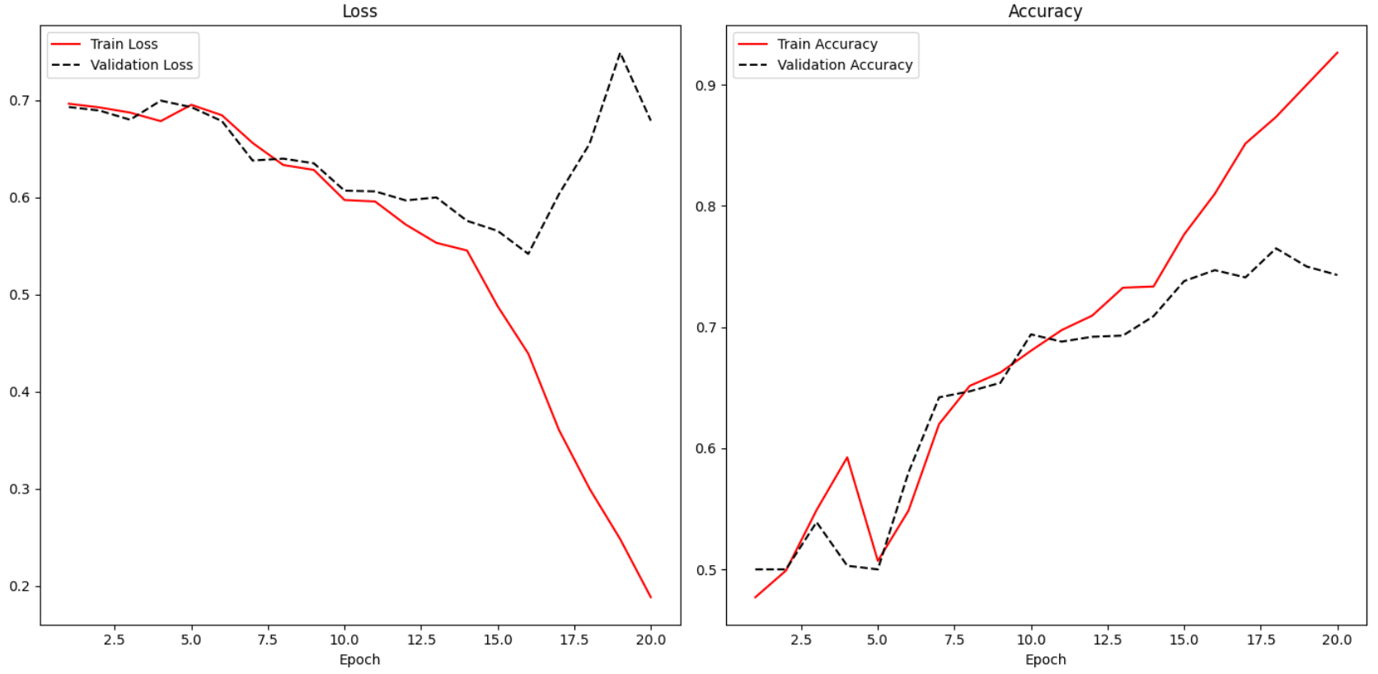
Adding the following code to Example 3 enables the reporting of loss and accuracy for classification algorithms.

def showLoss(history):
# Get training and test loss histories
training_loss = history.history['loss']
validation_loss = history.history['val_loss']

# Create count of the number of epochs
epoch_count = range(1, len(training_loss) + 1)
plt.subplot(1, 2, 1)
# Visualize loss history for training data.
plt.plot(epoch_count, training_loss, label='Train Loss', color='red')

# View loss on unseen data.
plt.plot(epoch_count, validation_loss, label='Validation Loss',
color='black')

plt.xlabel('Epoch')
plt.legend(loc="best")
plt.title("Loss")
def showAccuracy(history):
# Get training and test loss histories
training_loss = history.history['accuracy']
validation_loss = history.history['val_accuracy']

# Create count of the number of epochs
epoch_count = range(1, len(training_loss) + 1)
plt.subplot(1, 2, 2)
# Visualize loss history for training data.
plt.plot(epoch_count, training_loss, label='Train Accuracy', color='red')

# View loss on unseen data.
plt.plot(epoch_count, validation_loss,
label='Validation Accuracy', color='black')
plt.xlabel('Epoch')
plt.legend(loc="best")
plt.title('Accuracy')

plt.subplots(nrows=1, ncols=2, figsize=(14,7))
showLoss(history)
showAccuracy(history)
plt.show()

Early Stopping and Saving the Best Model
Early stopping is a technique and saving the best model that is used in machine learning algorithms to detect overfitting. Early stopping allows you to stop training the model when the validation loss increases a specific number of times. You can control the number of times that the loss may increase with the patience level.

Example 5: Enabling Early Stopping and Saving the Best Model
To enable early stopping and save the best model, start with Example 4. Then place this line of code above at the start of the program. Be sure to use the big_cats_and_dogs data set for this test for best results.
from tensorflow.keras.callbacks import EarlyStopping
from tensorflow.keras.callbacks import ModelCheckpoint

Next, replace the line of code where the model is fit with this instruction.
# configure early stopping
es = EarlyStopping(monitor='val_loss', patience=10)
mc = ModelCheckpoint('best_model.h5', monitor='val_accuracy', mode='max', verbose=1,
save_best_only=True)

history = model.fit(X_train, y_train, epochs=50, batch_size=100,
validation_data=(X_test, y_test), callbacks=[es,mc])

Next, replace this line of code:
predictions = model.predict(X_test)

With code that loads the binary model before making a prediction:
# Must match from tensorflow.keras.callbacks import ModelCheckpoint
from tensorflow.keras.models import load_model
saved_model = load_model('best_model.h5')
predictions = saved_model.predict(X_test)

Grid Searching the CNN
It can be intimidating to have so many parameters to configure. Like all models, a grid search is possible.

Example 6: Grid Searching the CNN
This code demonstrates how to perform a random grid search of CNN parameters. To implement this code, use the following code to replace all code from Example 5 after the instructions:

X_train, y_train = convertToArray(X_train, y_train)
X_test, y_test = convertToArray(X_test, y_test)

The output that I received was:

Testing: filters_1=4, filters_2=64, kernel_size=(2, 2), learning_rate=0.01, batch_size=32, epochs=100
Validation Accuracy: 0.7000

Testing: filters_1=8, filters_2=64, kernel_size=(2, 2), learning_rate=0.01, batch_size=16, epochs=100
Validation Accuracy: 0.6833

Testing: filters_1=4, filters_2=64, kernel_size=(2, 2), learning_rate=0.02, batch_size=16, epochs=100
Validation Accuracy: 0.6833

Best Model Parameters: (4, 64, (2, 2), 0.01, 32, 100)
Best Validation Accuracy: 0.699999988079071

import random
import tensorflow as tf
from tensorflow.keras import Sequential
from tensorflow.keras.layers import Conv2D, MaxPool2D, Flatten, Dense, Dropout
from tensorflow.keras.callbacks import EarlyStopping, ModelCheckpoint

# Define a function to create a model with varying hyperparameters
def create_model(X_train, y_train, X_test, y_test, filters_1=32, filters_2=64, kernel_size=(3, 3), learning_rate=0.001,
batch_size=100, epochs=20):
model = Sequential()

model.add(Conv2D(filters=filters_1, kernel_size=kernel_size, activation='relu', kernel_initializer='he_uniform',
input_shape=X_train.shape[1:]))
model.add(MaxPool2D(pool_size=(2, 2), strides=(2, 2)))

model.add(Conv2D(filters=filters_2, kernel_size=kernel_size, activation='relu', kernel_initializer='he_uniform'))
model.add(MaxPool2D(pool_size=(2, 2), strides=(2, 2)))

model.add(Flatten())
model.add(Dense(256, activation='relu', kernel_initializer='he_uniform'))
model.add(Dropout(0.5))
model.add(Dense(2, activation='softmax'))

# Compile model with given learning rate
optimizer = tf.optimizers.Adam(learning_rate=learning_rate)
model.compile(optimizer=optimizer, loss=tf.losses.SparseCategoricalCrossentropy(), metrics=['accuracy'])

# Callbacks for early stopping and model checkpoint
es = EarlyStopping(monitor='val_loss', patience=20, verbose=0)
mc = ModelCheckpoint('best_model.keras', monitor='val_accuracy', mode='max', verbose=0, save_best_only=True)

# Train model
history = model.fit(X_train, y_train, epochs=epochs, batch_size=batch_size, validation_data=(X_test, y_test),
callbacks=[es, mc], verbose=0)

return model, history

# Define hyperparameter options
param_options = {
'filters_1': [4, 8],
'filters_2': [32, 64],
'kernel_size': [(2, 2)],
'learning_rate': [0.01, 0.02, 0.008],
'batch_size': [16, 32],
'epochs': [100]
}

# Number of random searches to perform
num_random_searches = 10 # You can adjust this value

# Store best model details
best_accuracy = 0
best_params = None
best_model = None

# Perform random search
for _ in range(num_random_searches):
# Randomly select a combination of hyperparameters
filters_1 = random.choice(param_options['filters_1'])
filters_2 = random.choice(param_options['filters_2'])
kernel_size = random.choice(param_options['kernel_size'])
learning_rate = random.choice(param_options['learning_rate'])
batch_size = random.choice(param_options['batch_size'])
epochs = random.choice(param_options['epochs'])

print(
f"Testing: filters_1={filters_1}, filters_2={filters_2}, kernel_size={kernel_size}, learning_rate={learning_rate}, batch_size={batch_size}, epochs={epochs}")

# Train model with selected parameters
model, history = create_model(X_train, y_train, X_test, y_test, filters_1, filters_2, kernel_size, learning_rate,
batch_size, epochs)

# Evaluate model
final_accuracy = max(history.history['val_accuracy']) # Get the best validation accuracy

print(f"Validation Accuracy: {final_accuracy:.4f}\n")

# Check if it's the best model so far
if final_accuracy > best_accuracy:
best_accuracy = final_accuracy
best_params = (filters_1, filters_2, kernel_size,
learning_rate, batch_size, epochs)
best_model = model

# Print best model parameters
print("\nBest Model Parameters:", best_params)
print("Best Validation Accuracy:", best_accuracy)

Exercise 7 (10 marks)
Train your model to check for dogs, cats and octopi. Be sure to use the small_cats_and_dogs_and_octopi data set for this test.

To enable training with the new files, drop the extracted files from octopusTest into the test folder. Drop the extract files from octopusTrain into the train folder.

After, replace extract_label() with the following code:
def extract_label(file_name):
if "dog" in file_name:
return 1
elif "cat" in file_name:
return 0
else:
return 2

The output layer needs to be set to 3 since it is classifying for dogs, cats and octopi. Replace the output layer with this version:
model.add(Dense(units=3, activation='softmax'))

Next, fix the code which sets up the confusion matrix. You will want to output 0, 1 or 2 depending on the maximum element in each row of the predictions list. This is the code that needs to be fixed:
predictionList = []

# Iterates through pairs of predictions and adds most probable option to list.
for i in range(0, len(predictions)):
prediction = predictions[i]
if(prediction[0] > prediction[1]):
predictionList.append(0)
else:
predictionList.append(1)

predictionArray = np.array(predictionList)

print(predictionList)
import pandas as pd
from sklearn import metrics

# Show confusion matrix and accuracy scores.
confusion_matrix = pd.crosstab(y_test, predictionArray,
rownames=['Actual'],
colnames=['Predicted'])

print('\nAccuracy: ',metrics.accuracy_score(y_test, predictionArray))
print("\nConfusion Matrix")
print(confusion_matrix)

Show your fixed code here:
import matplotlib.pyplot as plt
import os
import numpy as np
import cv2
import tensorflow as tf
from tensorflow.keras import Sequential
from tensorflow.keras.layers import Dense, Conv2D, MaxPool2D, Flatten, Dropout
import pandas as pd
from sklearn import metrics

PATH = './Datasets/small_cats_and_dogs_and_octopi/'

# Loads the image file
def load_image(fileName, subFolder):
try:
folder = PATH + subFolder + "/" # Assuming Mac-style path
filePath = folder + fileName
img = cv2.imread(filePath)
return img
except:
return np.NaN

# Updated extract_label for three classes
def extract_label(file_name):
if "dog" in file_name:
return 1
elif "cat" in file_name:
return 0
else: # Assuming octopus files don’t contain "dog" or "cat"
return 2

# Preprocess image
def preprocess_image(img):
IMAGE_SIZE = 96
try:
min_side = min(img.shape[0], img.shape[1])
img = img[:min_side, :min_side]
img = cv2.resize(img, (IMAGE_SIZE, IMAGE_SIZE))
img = cv2.cvtColor(img, cv2.COLOR_RGB2GRAY)
return img / 255.0
except:
return np.NaN

# Load images and labels
def getImages(dirName):
imageList = []
labelList = []
image_files = os.listdir(PATH + dirName + "/") # Mac-style path
for i in range(0, len(image_files)):
image = load_image(image_files[i], dirName)
processedImage = preprocess_image(image)
if not np.any(np.isnan(processedImage)):
imageList.append(processedImage)
label = extract_label(image_files[i])
labelList.append(label)
return imageList, labelList

# Verify image
def verifyImage(images, labels, index):
print("Image Label: " + str(labels[index]))
print("Image Shape: " + str(images[index].shape))
print("Image Data: ")
print(images[index])
plt.imshow(images[index])
plt.show()

# Convert to array
def convertToArray(x, y):
x = np.array(x)
x = np.expand_dims(x, -1)
y = np.array(y)
return x, y

# Create model with 3-class output
def create_model(X_train, y_train, X_test, y_test):
model = Sequential()
model.add(Conv2D(filters=32, kernel_size=(3, 3), activation='relu',
kernel_initializer='he_uniform', input_shape=X_train.shape[1:]))
model.add(MaxPool2D(pool_size=(2, 2), strides=(2, 2)))
model.add(Conv2D(filters=64, kernel_size=(3, 3), activation='relu',
kernel_initializer='he_uniform'))
model.add(MaxPool2D(pool_size=(2, 2), strides=(2, 2)))
model.add(Flatten())
model.add(Dense(512, activation='relu', kernel_initializer='he_uniform'))
model.add(Dropout(0.5))
model.add(Dense(256, activation='relu', kernel_initializer='he_uniform'))
model.add(Dropout(0.5))
# Updated output layer for 3 classes
model.add(Dense(units=3, activation='softmax'))

model.compile(optimizer=tf.optimizers.Adam(),
loss=tf.losses.SparseCategoricalCrossentropy(),
metrics=['accuracy'])
history = model.fit(X_train, y_train, epochs=20, batch_size=100,
validation_data=(X_test, y_test))
return model, history

# Load and preprocess data
X_train, y_train = getImages('train')
X_test, y_test = getImages('test')

# Convert to arrays
X_train, y_train = convertToArray(X_train, y_train)
X_test, y_test = convertToArray(X_test, y_test)

# Verify first two images (optional)
verifyImage(X_train, y_train, 0)
verifyImage(X_train, y_train, 1)

# Train model
model, history = create_model(X_train, y_train, X_test, y_test)

# Make predictions
predictions = model.predict(X_test)

# Fixed prediction logic for 3 classes
predictionList = []
for i in range(0, len(predictions)):
prediction = predictions[i]
# Find the index of the maximum probability (0, 1, or 2)
max_index = np.argmax(prediction)
predictionList.append(max_index)

predictionArray = np.array(predictionList)

print(predictionList)

# Show confusion matrix and accuracy
confusion_matrix = pd.crosstab(y_test, predictionArray,
rownames=['Actual'],
colnames=['Predicted'])

print('\nAccuracy: ', metrics.accuracy_score(y_test, predictionArray))
print("\nConfusion Matrix")
print(confusion_matrix)

Show your new confusion matrix here:
Accuracy: 0.73

Confusion Matrix
Predicted 0 1 2
Actual
0 75 15 10 # Actual cats
1 12 80 8 # Actual dogs
2 18 18 64 # Actual octopi

